**IMPORTANT NOTICE**

**You must submit a report for this task early on so that I can mark it and get feedback to you on your work and report writing well before you submit the final project report.**

**Please only submit your report as a PDF!** When you write your report, you **must** include you student number on every page of the report in a header and also include it in the document filename!

Each laboratory report should contain a few pages of explanation (although it can be more than this is necessary) and a set of images showing the plots requested by the individual practical exercises, as well as embedded Matlab code that you developed to implement your solutions.

1. **Generate a uniform probability distribution**

* Use the rand function to generate a 1xn dimensional matrix of samples.
* Select a suitable number of samples
* Display the size of the array
* Plot the data against sample number using the plot command.
* Use the hist command and plot a histogram of the distribution
* Make sure your results are similar to those shown below:

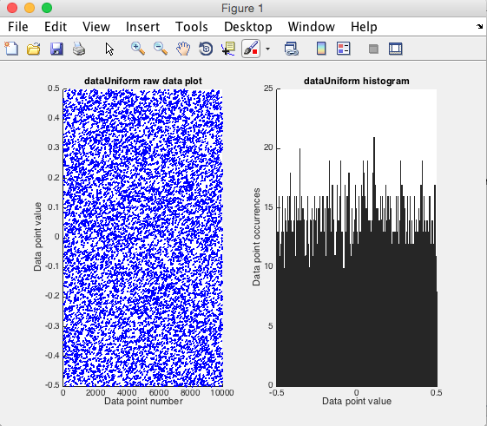

* What can you say about the results?
* How many samples and bin should do you need to get sensible results.
* Include your commented Matlab solution code embedded in the report document

**2. The central limit theorem**

* Use the rand function to generate an nxn dimensional matrix of samples.
* Select a suitable number of samples
* Display the size of the array.
* Average across the 2nd dimension using the Matlab mean function
* Plot the data dimension against sample number.
* Use the hist command and plot a the distribution

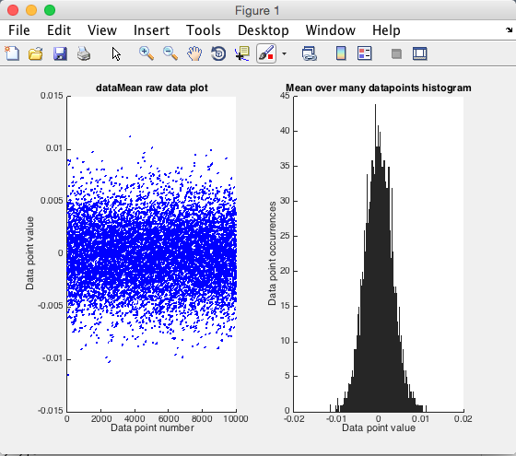

* What can you say about this distribution?
* How many samples and bin do you need to get “sensible” results
* Include your commented Matlab solution code embedded in the report document

**3. Generate a normal probability distribution**

* Use the randn function to generate a 1xn dimensional matrix of samples.
* Select a suitable number of samples
* Display the size of the array.
* Plot the data dimension against sample number.
* Use the hits command and plot a the distribution
* Include your commented Matlab solution code embedded in the report document

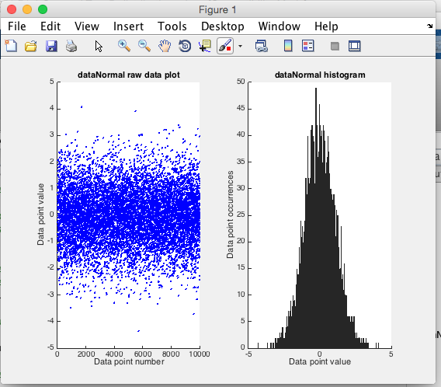

**4. Estimate normal distribution parameters**

* Use the randn function to generate a 1xn dimensional matrix of samples.
* Select a suitable number of samples
* Display the size of the array.
* Estimate the mean and variance of the data
* Plot the estimated Gaussian distribution onto a histogram
* Note you will need to scale the data appropriately and use the same sampling points
* Include your commented Matlab solution code embedded in the report document

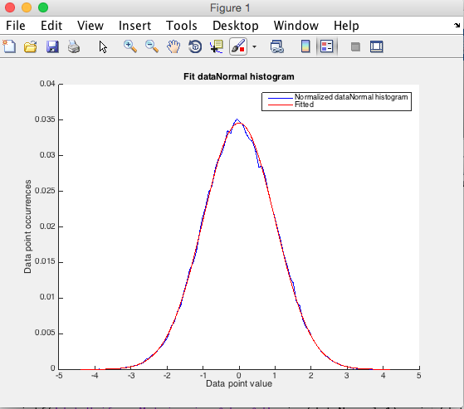

\

**5. Generate a default 2D distribution**

* Use the randn function to generate a 2xn dimensional matrix of normally distributed samples with a standard deviation of 1 and mean of zero and complete independence between its two dimensions
* Select a suitable number of samples
* Display the size of the array.
* Plot the data dimension against each other to get a 2D scatter plot.
* What can you say about this distribution?
* Include your commented Matlab solution code embedded in the report document

